Team members:

Rodolphe Eugene

Esperandieu Alfred

Acka Armah

Fit Footwear Co.

reugene2284@ember.hpc.lab DB Name:

ealfred2285@ember.hpc.lab reugene2284_DB_FitFootwearCo aarmah4798@ember.hpc.lab

Executive summary of business, problem, and solution.

Fit Footwear Co. has been in business for over 3 decades, selling our products in stores and online as well. We aim to satisfy athletes of all sports with our shoe-wear products. We have endorsement deals with some of the most well-known athletes of all time. To name a few of the athletes we have deals with:

* Lebron James
* Usain Bolt
* Lionel Messi

These individuals listed above are the most prominent figures representing our company, and our goal is to continue to make high-quality sport wear for today’s generation. With that being said, our company has been working on making improvements to the variety of products we provide to our consumers.

One of the company’s biggest issues is conflicts with data redundancy in updating the spreadsheet containing information about invoices, customer information, and orders. To resolve this issue, the unique constraints can be used on columns on an entity within the database, which will ensure that the values in specified columns are unique. Also, a primary key can be used to prevent data duplication because the primary key will be used to identify a unique record in a table. Also, indexing the columns will reduce data redundancy as well. Lastly, normalization is an alternative to eliminating data duplications. To further resolve data redundancy issues, unique auto-generated values will be assigned to each Inventory item. In case a value is not assigned for each product in the inventory.

Also, the company is having issues Identifying sell records due to unorganized information on customers and orders. A solution to this issue is to create multiple tables to represent each piece of information being processed by the company. For example, there could be a table for Orders, Customers, and Invoices. All of those tables will have information regarding each customer’s order and are related since they all may contain the customer’s Information. As a result, making it easier for the company to retrieve data since they all are connected. Assigning a specific Identification number to each employee, invoice, and Order will also reduce the chances of duplication when looking for specific customer information.

Define Problems and Constraints, Define objectives

Problems:

* conflicts with data redundancy when updating the company’s spreadsheet
* issues Identifying sell records due to unorganized information on customers and orders

Constraints:

* VENDORS must purchase at least 40 products of any PRODUCT
* INVOICES , ORDER, and EMPLOYEE table should not contain any NULL values, and each must be assigned a unique key.
* SALES_REPORT should not contain any NULL values
* STORES must carry at least 1 BRAND.

Objectives:

Our objective is to create a database that will help Fit Footwear Co. to have much higher control over customer information and orders. More importantly, to improve the company’s data accuracy and ease of data access by avoiding data redundancy.

Define scope and boundaries with business rules (half to full page)

Entities: Product (Basketball_Shoes, Running_Shoes, Soccer_Cleats), Inventory, Invoice, Customer, ProductVendor, Order, Store, Employee, SalesReport, CustomerReview, Brand, CRM (Customer Relationship Management

Business Rules: possible Business Rules, but can be reduced

* Each product may have its inventory record.
* Many products can belong to the same brand, but each product is associated with only one brand.
* A vendor may supply multiple inventories.
* A customer can place multiple orders, but each order belongs to only one customer.
* A customer may own multiple brands.
* A customer can write multiple reviews, but each review is written by only one customer.
* Each customer has only one CRM record.
* Each order has a single invoice.
* A store can have multiple employees, but each employee works at one store.
* An employee can generate multiple sales reports, but each report is generated by only one employee.
* A sales report can be generated for one store, but each store can have multiple sales reports.

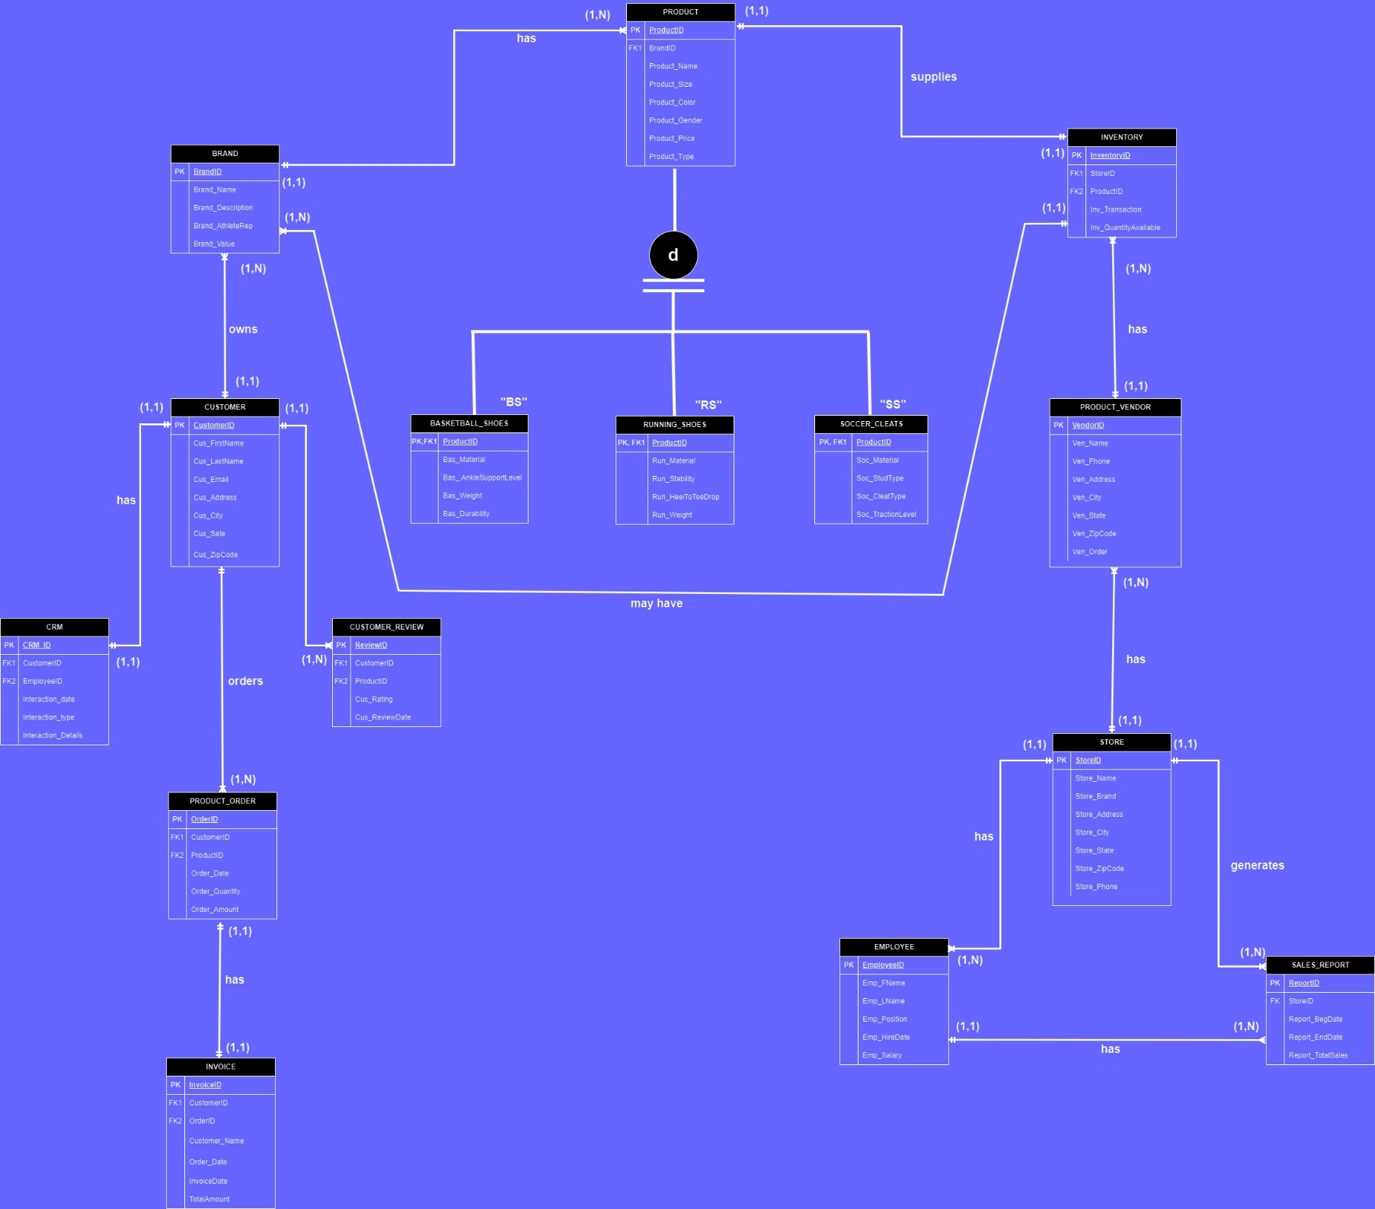EERD with Crow’s Foot format (include keys, relationships, attributes)

SQL dump of (show only first page) database (mysqldump)

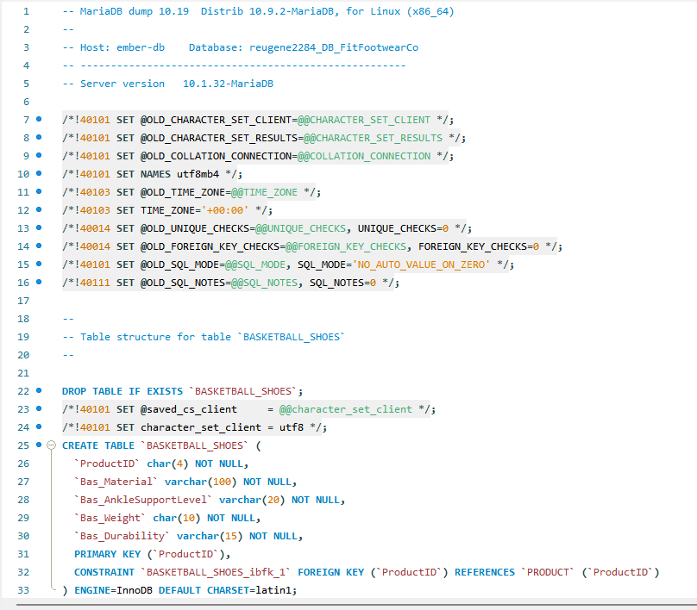

Output of a sql query to show a specific invoice based on a customer name and date of purchase, also include SQL code

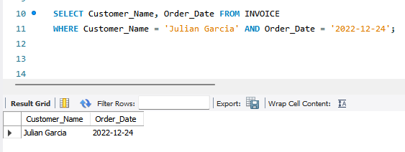SQL Code and Output:

Output of sql query to show a current inventory of all products sold within a date range, also include SQL code

(I used ORDER BY Order_Date to get the output in chronological order)

SQL Code and Output:

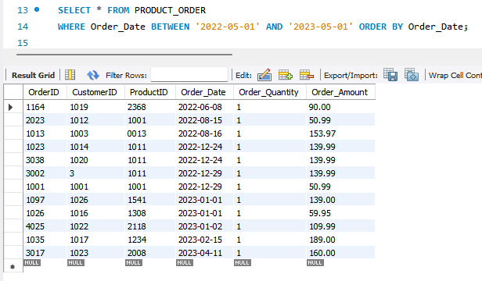

Output of sql query to show a current inventory of all products that match one specific type, also include SQL code

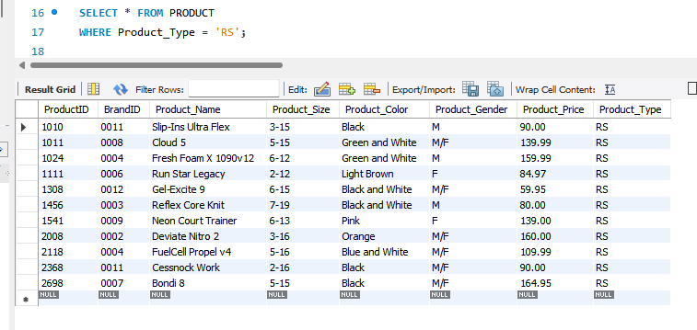SQL Code and Output:

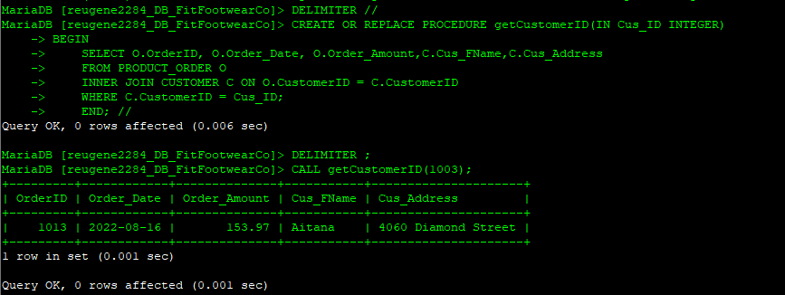Output of sql stored procedure that allows user to pass in a value and in order to join two tables to produce an output (you decide the attributes), also include sql code

SQL code used to insert new product into product table (show all attributes)

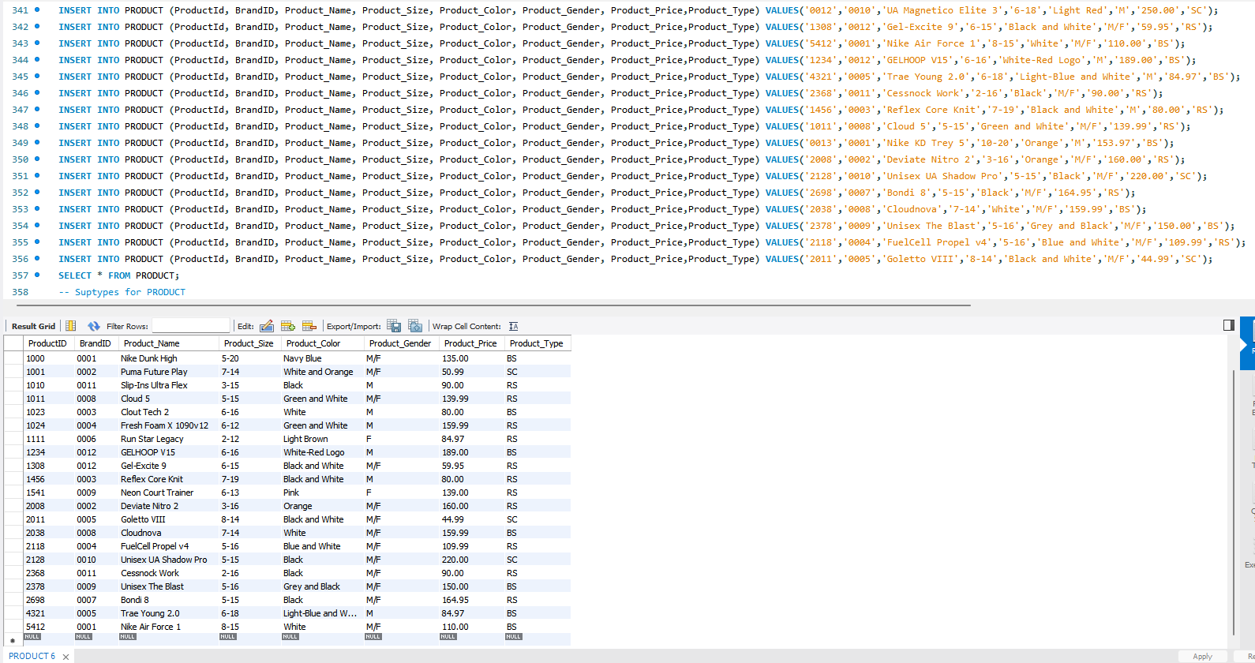

SQL code to generate a new invoice, you decide on product and customer informations

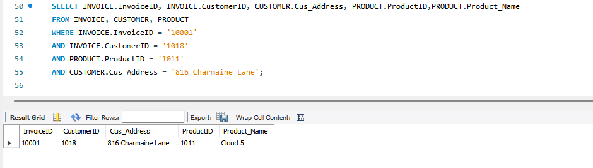SQL Code and Output:

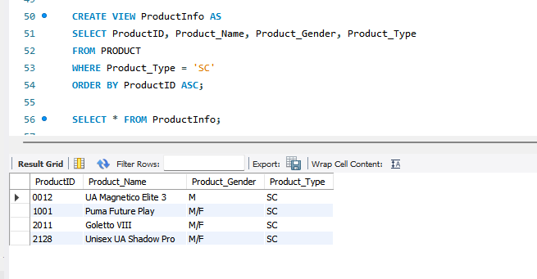Output of a virtual table (of your choice), also include SQL code

Show data dictionary of tables (see fig 1)

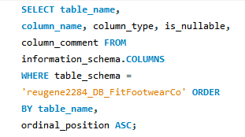SQL CODE:

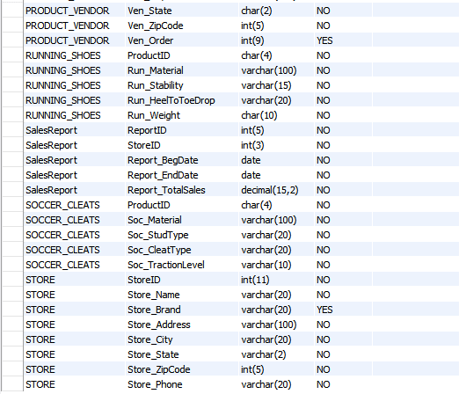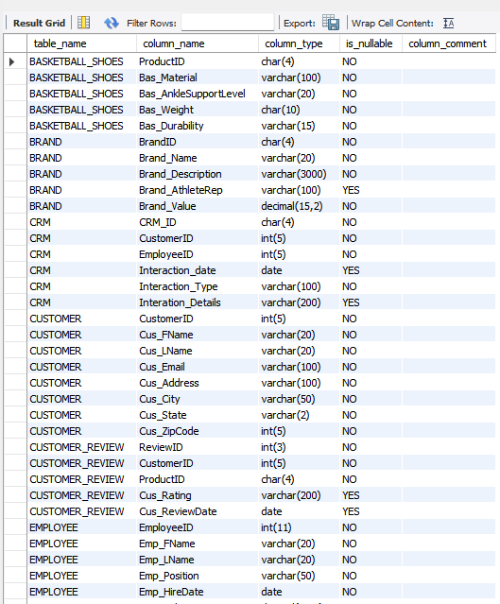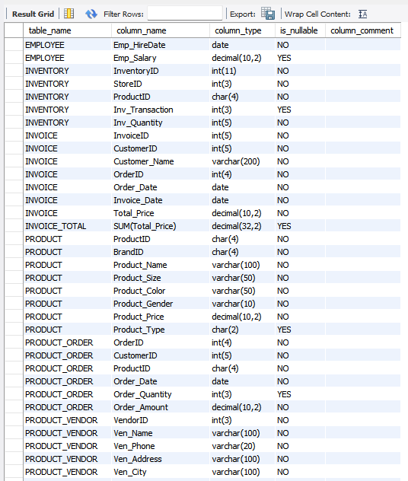SQL Output:

Summary of your database solution as conclusion to business proposal (minimum 2-3 paragraphs)

The two problems highlighted were fairly simple to justify. First, the conflicts with data redundancy in updating the spreadsheet containing values information on customers and orders were handled using unique constraints on a few tables containing customer information. Another key to resolving this problem was to use the primary key to force unique identification values for customers, orders, invoices, and Employees, to say the least. In case, the individual updating the spreadsheet forgets to add a unique key, most of the tables in the database do not allow NULL values. It will alert the end user that there is an empty slot. Also, the normalization process is also being used to reduce data redundancy.

Secondly, the problem with identifying sell records due to unorganized information on customers and orders took a bit more time to resolve. The first approach was to create multiple tables in the database to break down the information being processed by the company. There is a table for Orders, Customers, and Invoices. A unique value must be entered for each row in the table. As a result, this process makes it easier for end-users to access data since every entity is on its own and each entity contains relatable information. More importantly, the company can now access data effortlessly and with more accuracy. In other words, greater control over data will be present from now on.

Overall, the entire database is aiming to make the component more efficient with Sales, Invoices, Customer information, and how fast the company can retrieve the data needed. This database will fulfill that requirement due to its adaptation of a handful of SQL commands that heavily supports data integrity.